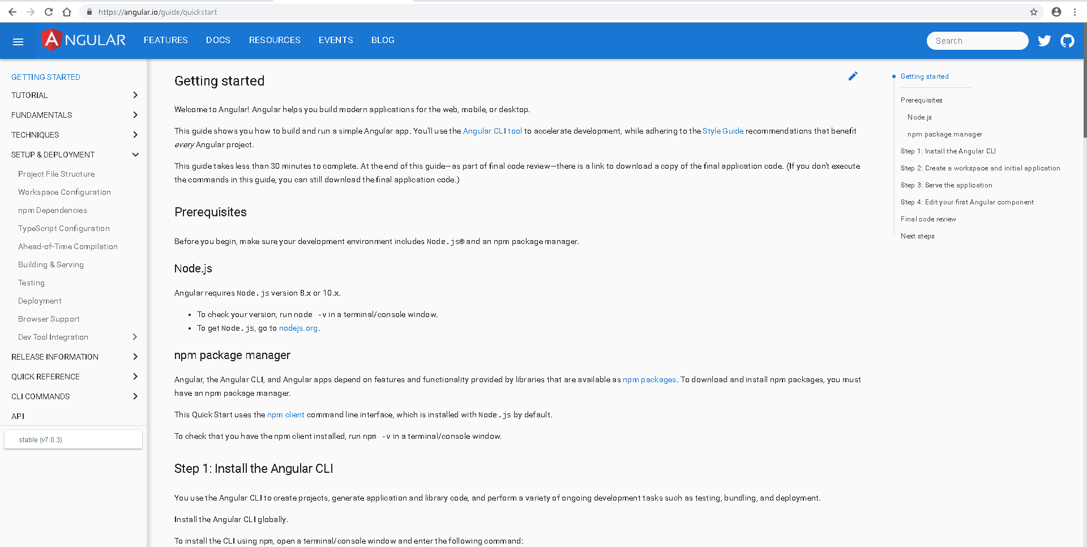

Welcome to Angular! Angular helps you build modern applications for the web, mobile, or desktop.

This guide shows you how to build and run a simple Angular app. You'll use the [Angular CLI tool](https://angular.io/cli) to accelerate development, while adhering to the [Style Guide](https://angular.io/guide/styleguide) recommendations that benefit *every* Angular project.

